Dear Southeastern Indiana School Insurance Trust:
We’re excited to welcome you to the RxBenefits family. Thank you for giving us the opportunity to bring best-in-class pharmacy benefits to your members, while working on your behalf to help keep the pharmacy benefit affordable. As your pharmacy benefits optimizer, we want to work hard every day to ensure both your members and your plan get the maximum value possible from the pharmacy benefit. This packet is designed exclusively for you and includes:
- Client & Member Services Overviews
Our professional client and members services representatives are available to support you and your members should any questions or issues arise.
- RxBenefits’ Account Management Support Team Contacts
These will be your strategic and day-to-day champions at RxBenefits. You are their priority, so reach out any time!
- Ongoing Communications Outline
You can expect monthly and quarterly reporting from your Account Management Team. You and your members can also expect regular communications about program updates, current events, and key initiatives.
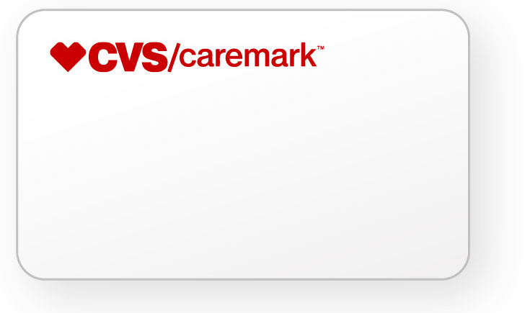
Your members should have received a Member Launch Kit. If they need to fill a prescription and have not yet received their kit or lost their card(s), you can supply them with the information below to use as a temporary ID card at the pharmacy to process their immediate refill request(s).

RxBIN: 004336
RxPCN: ADV
RxGRP: RX2169

If your members have any questions regarding their prescription drug coverage, they can contact RxBenefits’ Member Services team directly by calling 800.334.8134 or email CustomerCare@rxbenefits.com.
As always, RxBenefits’ Client Services team is here to support your daily needs and address any questions or concerns you may have. You can reach them Monday – Friday from 7:00 a.m. to 6:00 p.m. CT by calling 866.769.5987 or emailing ClientServices@rxbenefits.com. We are thrilled to be partnering with you to take your pharmacy benefit to the next level.
Sincerely,
Your RxBenefits Team

